**Lab Computing Resources**

# **Inabia VPN Server**

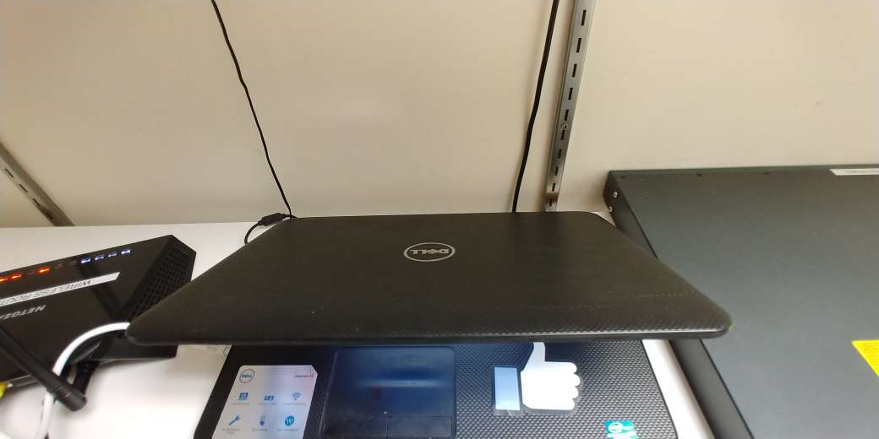

# **Albany:**

**Laptop Specifications**

Make: Toshiba

RAM: 8GB

CPU: Intel Core i7. 2.40GHz

Charger: round tip plug (couldn’t find the power adapter part)

HDD: 750GB

Monitor: 15.6” LED

OS: Windows 10 Pro

**Overall Feel of the Laptop:** Toshiba Laptop – The hardware is old. It is running very slow because it is heating up.

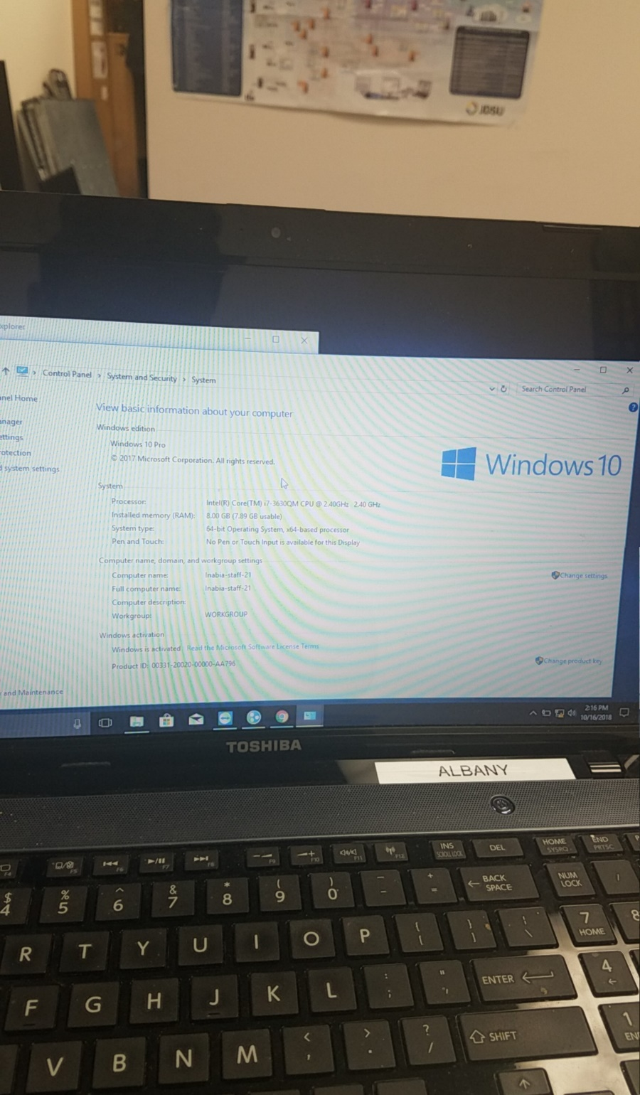

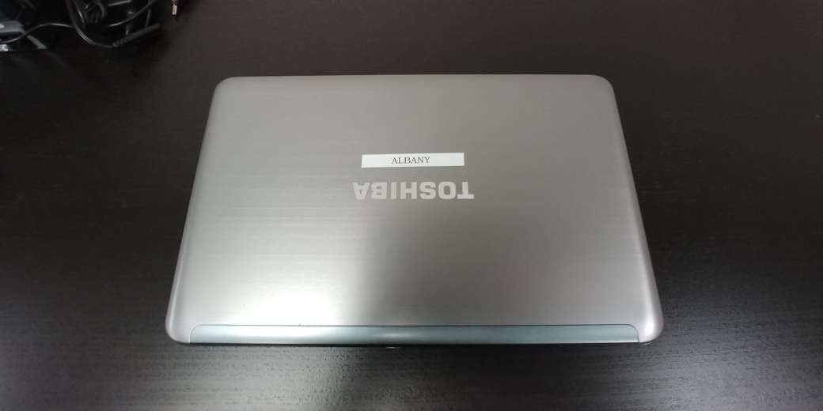

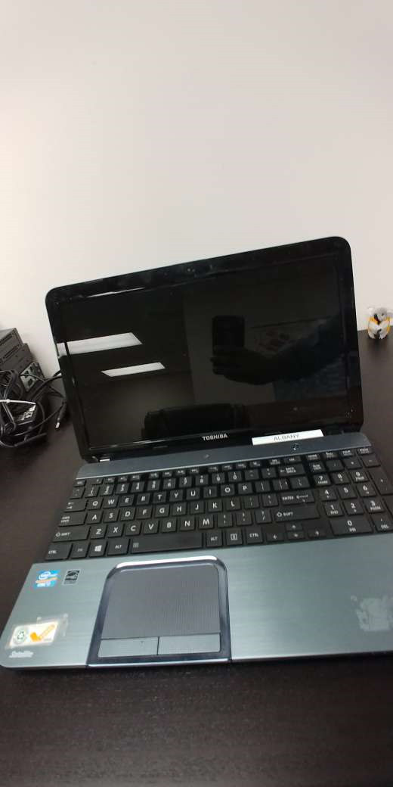

# **Buffalo:**

**Laptop Specifications**

Make: Lenovo

RAM: 6GB

CPU: Intel Core i5. 2.30GHz

Charger: USB type plug

HDD: 1TB (has some partitions)

Monitor: 15.6” LED

Operating System: Windows 10 Home

**Overall Feel of the Laptop:** Lenovo Laptop – The monitor is broken and needs to be put in a certain position for it to work fine. Icons on bottom right part of the taskbar keep moving due to broken piece of screen holder.

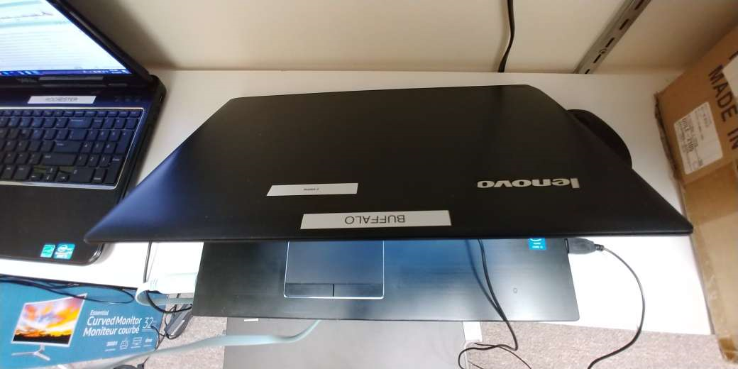

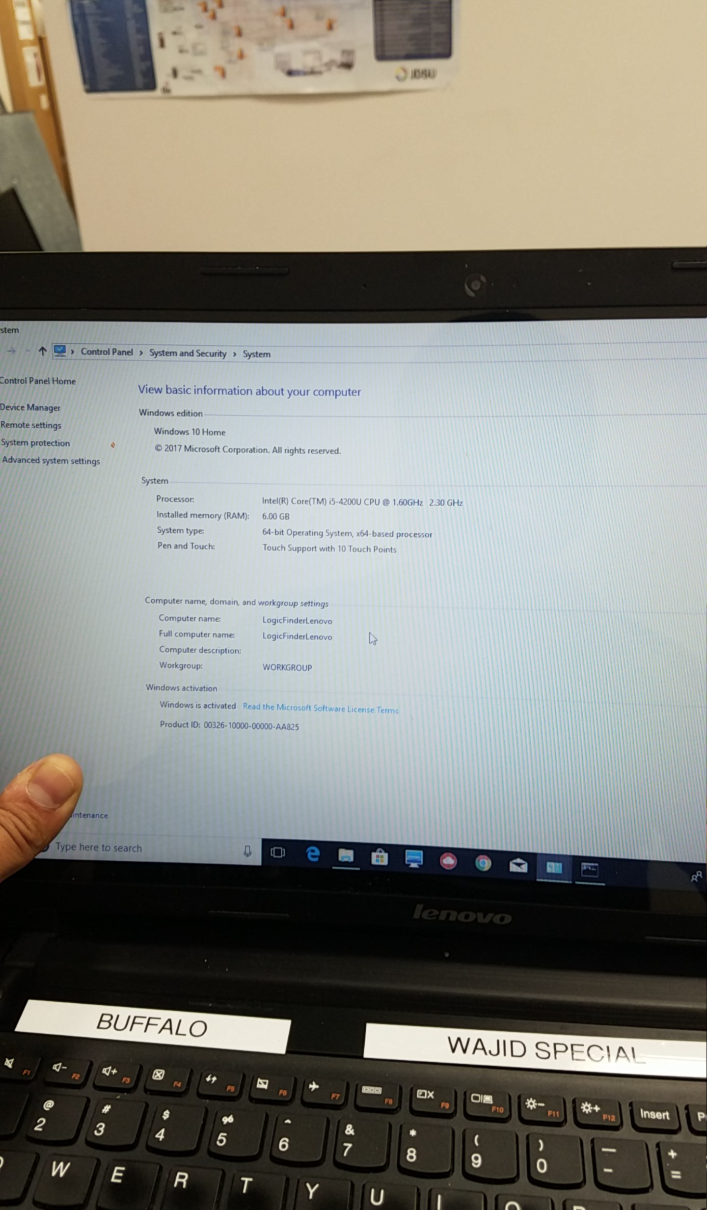

# **Rochester:**

**Laptop Specifications**

Make: Dell

OS: Windows 10 Pro

RAM: 8GB

CPU: Intel Core i5. 2.40GHz

Charger

HDD

Monitor

**Overall Feel of the Laptop :**

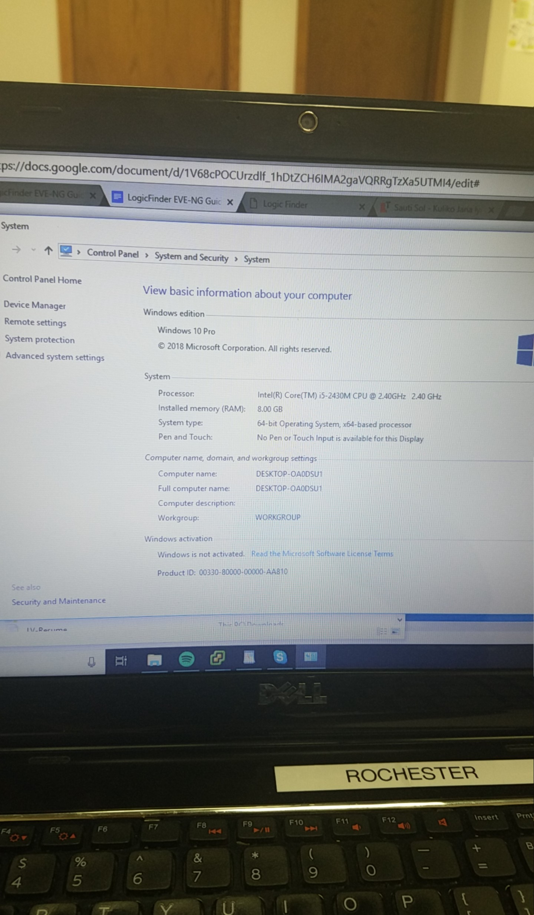

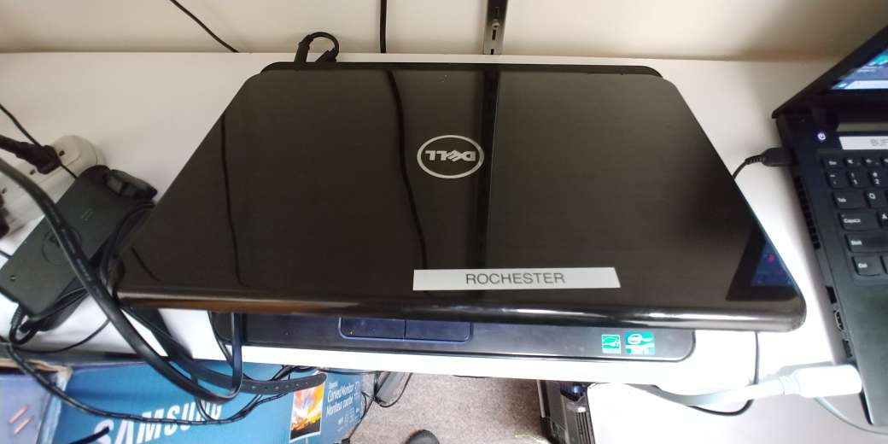

# **Kyoto:**

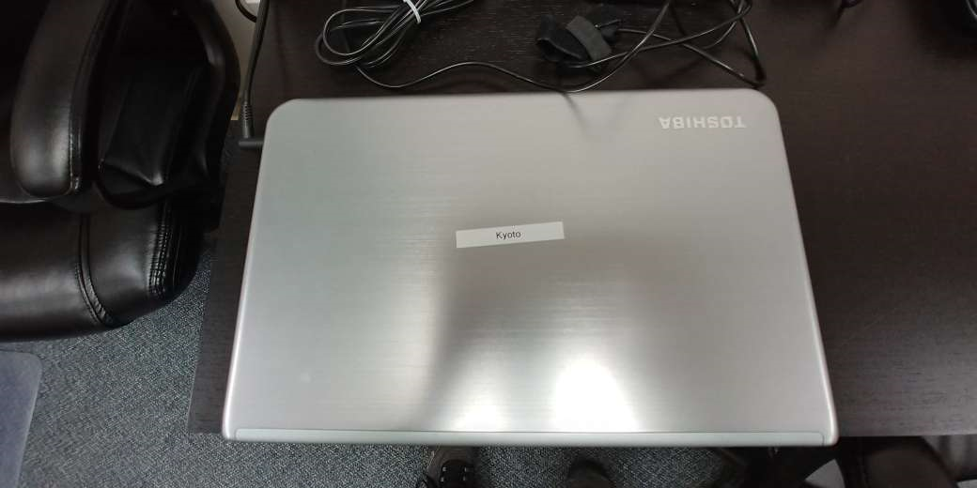

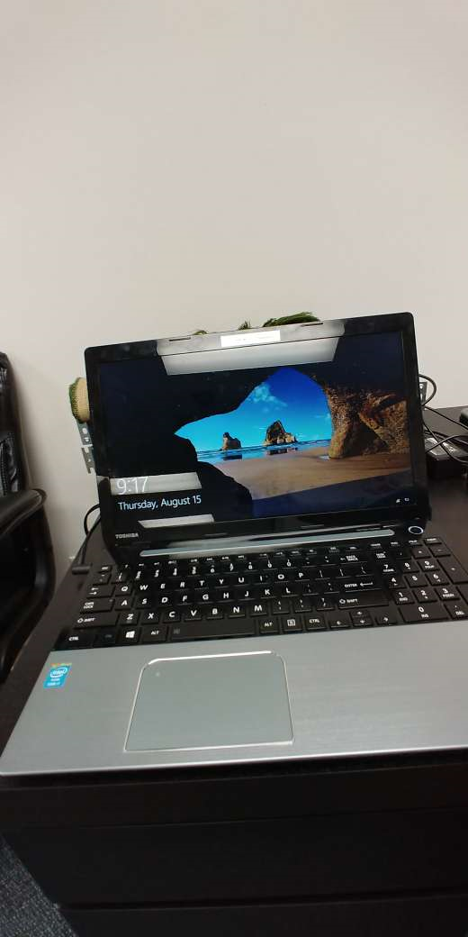

# **Austin Server**

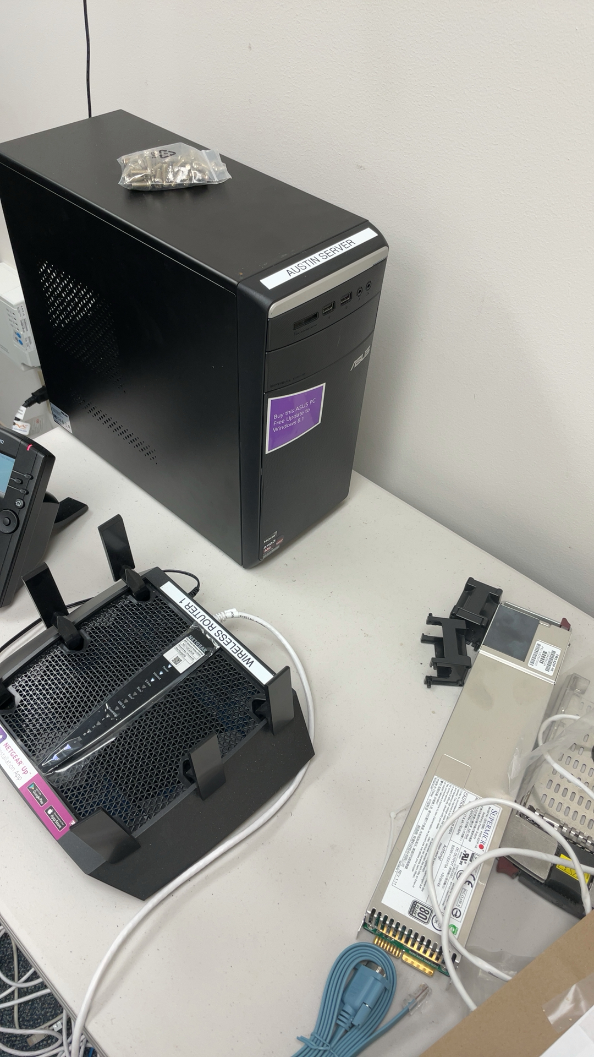

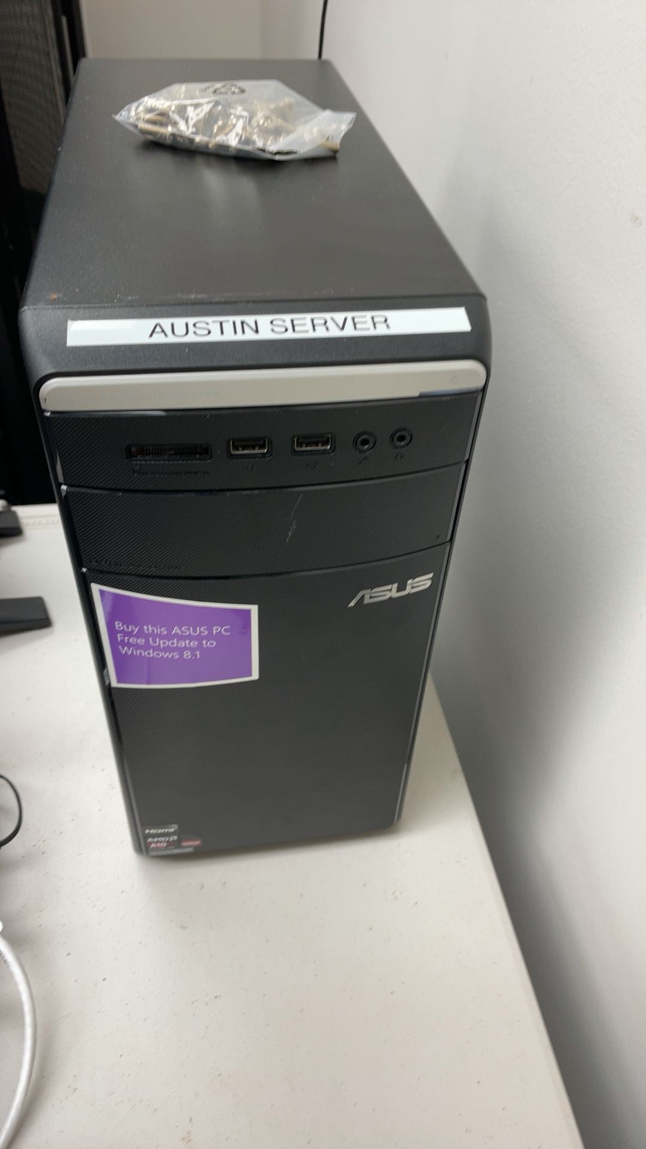

# **Wireless Router**

Netgear Nighthawk x6s

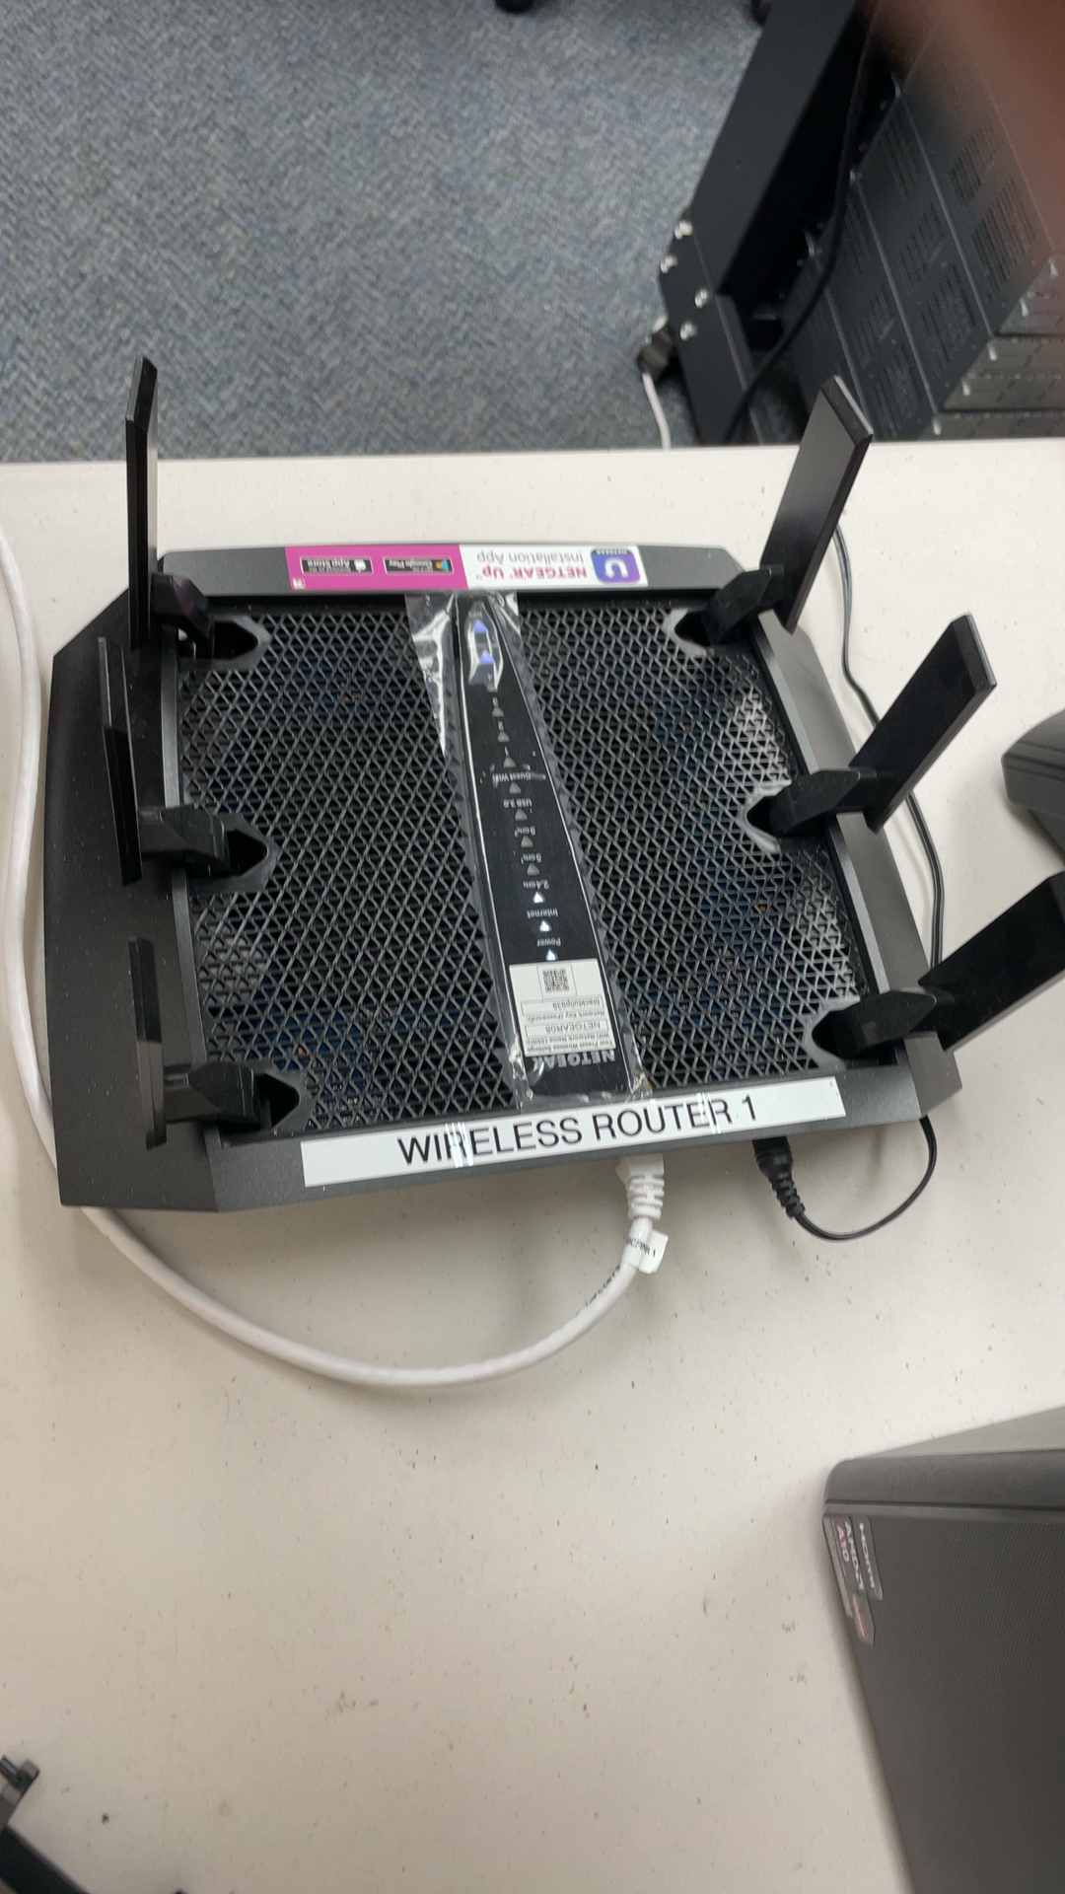

# **WiFi Extender**

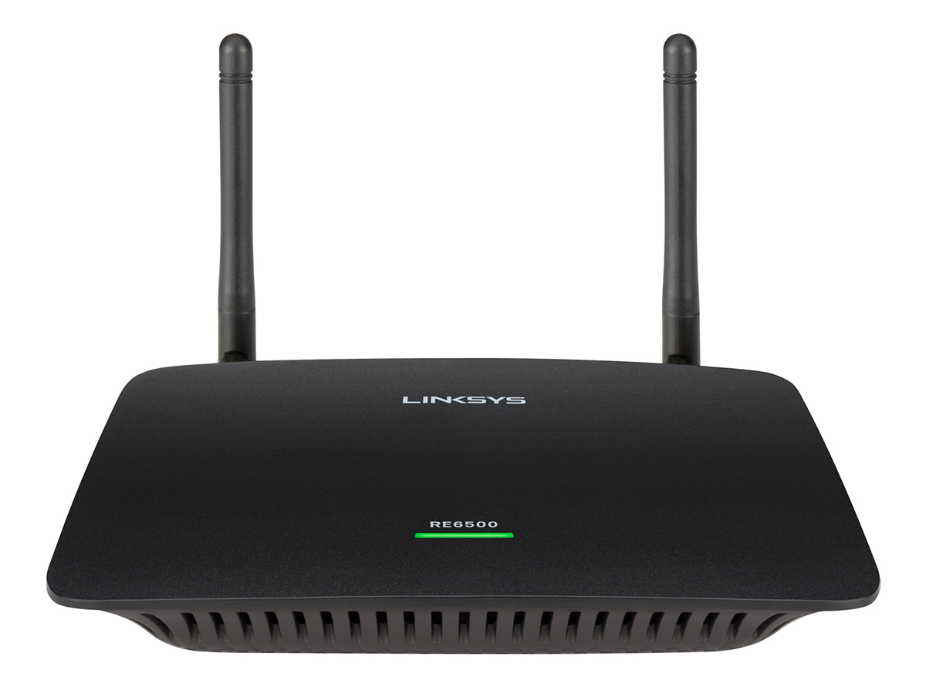

ma